**Auto Marking Program Guideline**

**Things to do for OpenFlow Agent Test**

1. Before you make a program, you consider a rules that we provide
   1. Below message type is sequence of Openflow message. You must be keep sending request message sequentially.
      1. HELLO : This message try to connect to Openflow server
      2. FEATURES_REPLY: It is to response information about function of switch
      3. STATS_ REPLY: It is to response information about function of switch
      4. GET_CONFIG_ REPLY: It is informed to information about how to set of switch configuration.
      5. BARRIER_ REPLY : It is to response message about validation that command of controller
      6. STATS_ REPLY: It is to response information about switch description
      7. ROLE_ REPLY: It is to response information about role change (e.g : master->slave)
      8. PACKET_IN: It is to response information about how to activate of data packet. If switch has a packet information in flow table , switch will be act. But if switch hasn't a packet information in flow table, switch will request packet information to server.
2. Don’t use mininet for this test. If you use mininet, your score is zero

**What you can get in this project**

Today's network trend is changing to SDN. And OpenFlow protocol is representative In southbound of SDN. So if you do this test, you can to understand trend of network.

**List of grading items**

1. Openflow Agent test (You keep the rule of openflow message flow)

Mission1: HELLO Message and Response about 'HELLO' sent from server

Mission2: FEATURES_REPLY Response about ‘FEATURES_REQUEST sent from server

Mission3: STATS_ REPLY: Response about ‘STATS_REQUEST sent from server

Mission4: GET_CONFIG_ REPLY: Response about ‘GET_CONFIG_REQUEST sent from server

Mission5: BARRIER_ REPLY: Response about ‘BARRIER_REQUEST sent from server

Mission6: STATS_ REPLY: Response about ‘STATS_REQUEST sent from server

Mission7: ROLE_ REPLY: Response about ‘ROLE_REQUEST sent from server

Mission8: PACKET_IN: Response about ‘PACKET_IN sent from server

1. Don’t use mininet to test. if we checked you use mininet, your score just 0 score.

**How to test?**

1. Approach *166.104.143.225/index* through your web browser (Internet Explorer, Chrome, Firefox and etc.)

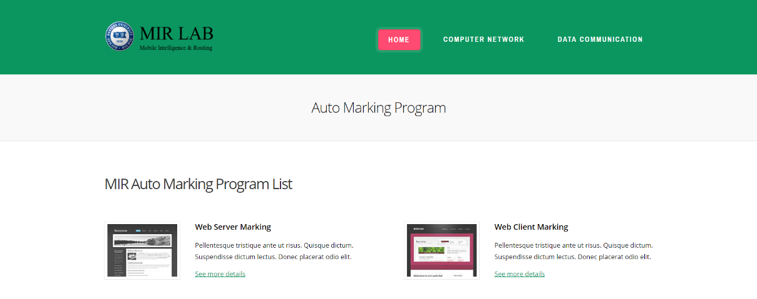

1. You have to choice in list association with your project

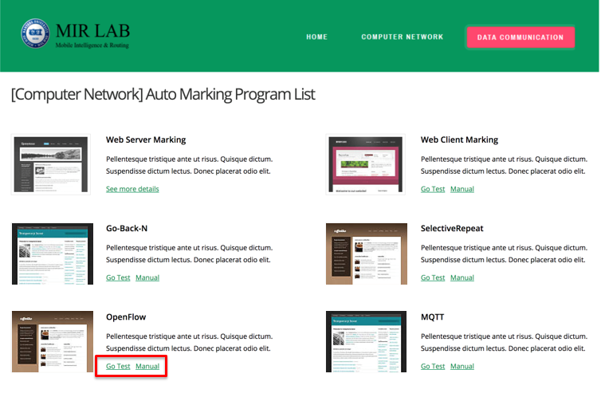

1. Fill out your information on blank.

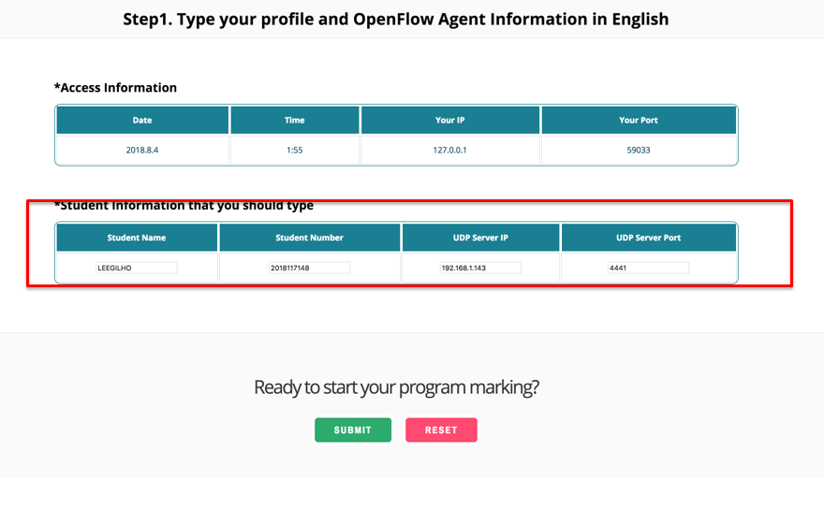

* + - * 1. Student Number(2017xxxxx)
        2. Student Name (Should be written in English)
        3. Your Web Server IP Address. If you are hard to find your global IP, refer to Current Connection Info in case you approaches this web site with the same computer
        4. Port that you assign for your Web server, Check this out on your Source Code

1. In this step, you check to mission that we provide before run your program

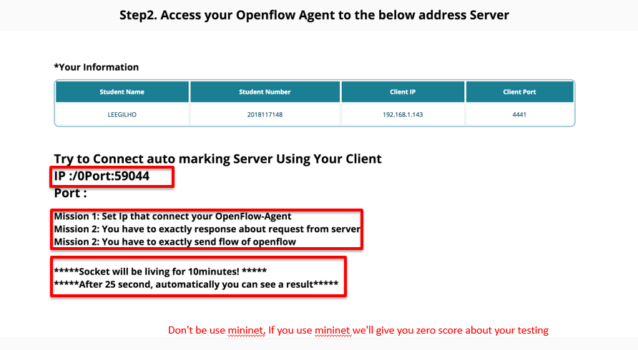

* + - * 1. You must be a think before run a your agent of openflow

1. Before this step, you have to set IP and PORT we gave
2. After 25 second, your test will be a end
3. Socket that you use is a setting that end after 10minute. So after click submit button, for 10minute your test is must be a end.
4. Result Page

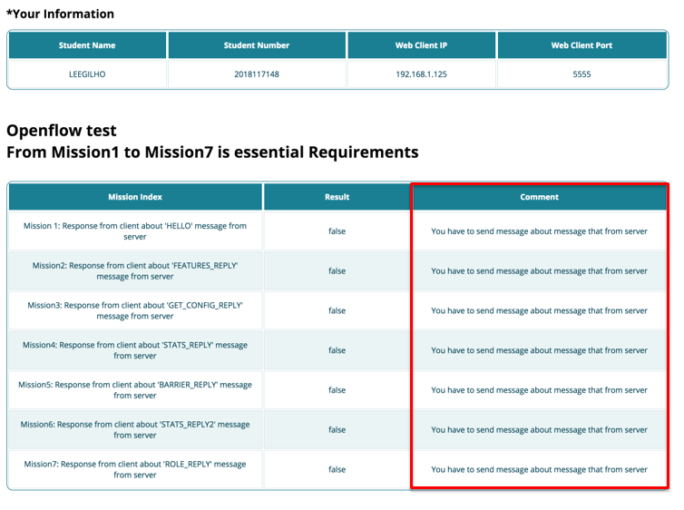

1. You can see what is wrong or correct with Reason